**1 INTRODUCTION**

**1.1 overview**

A thumbnail is a clickable, visual icon that represents the content of a

You tube Video, thumbnails are used on every you tube video, and are considered

A major factor in a video’s click- through –rate and views.

**1.2 purpose**

The purpose of a you tube thumbnails is to give viewers a visual preview of the video content and entice them to click on it.

**2 PROBLEM DEFINITION & DESIGN THINKING**

**2.1 Empathy Map**

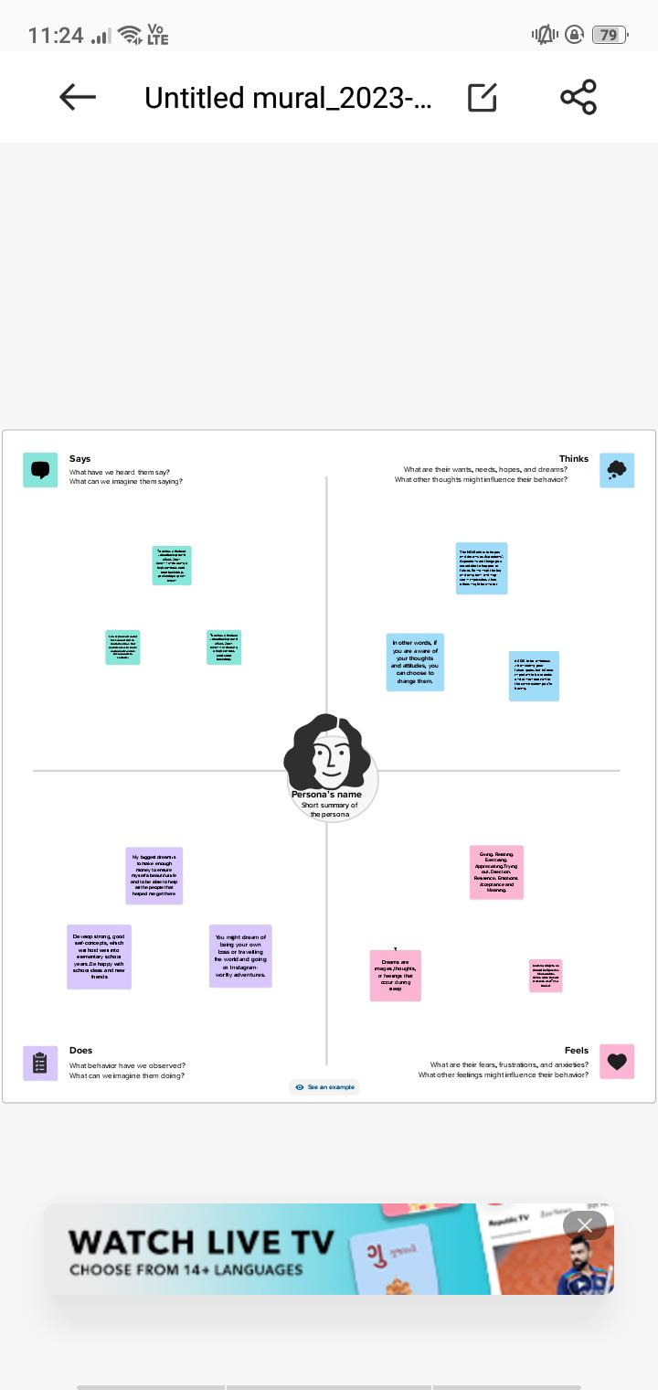

**2.2 Ideation & Brainstorming Map**

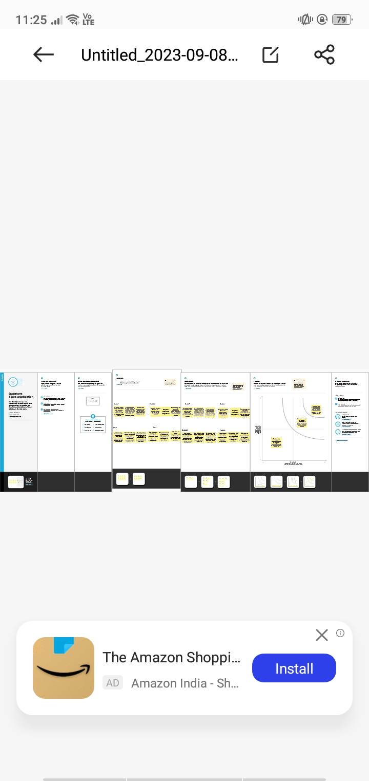

**3 Result**

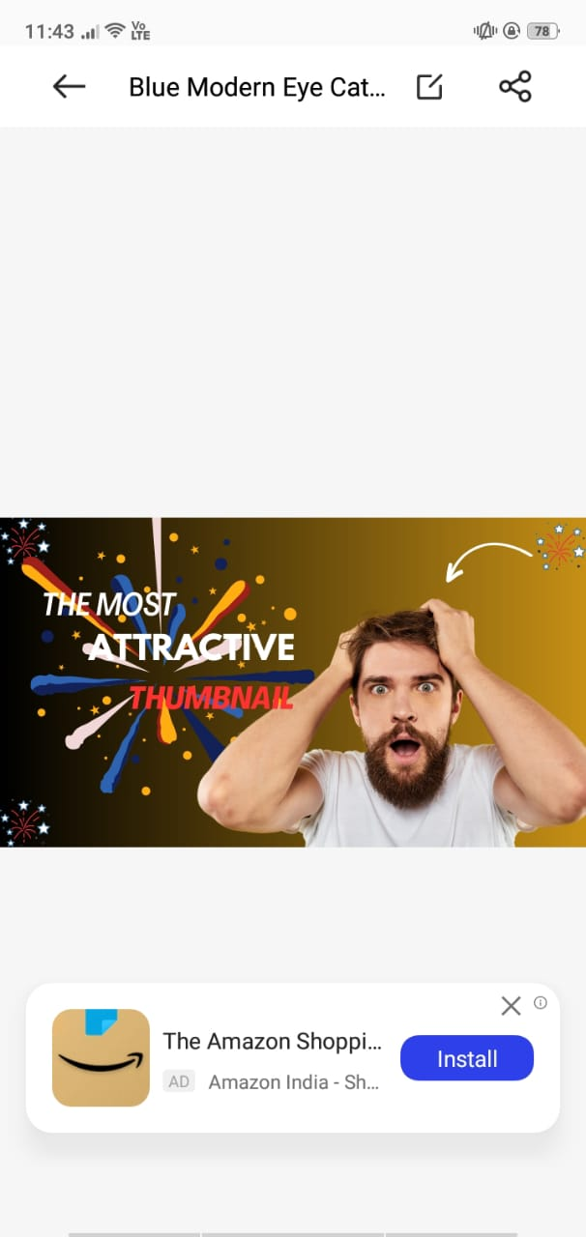

**4 ADVANTAGES & DISVANTAGES**

**4.1 Advantages**

The most straightforward advantage of thumbnails is that they allow your viewers to scan the video for content, in case they are interested in a specific portion instead of the whole video, and then seek back or forward to the desired point.

**4.2 Disadvantages**

However, there are a few disadvantages as well. Software applications are needed for producing thumbnails. Compared to normal image processing, extra coding is required for thumbnails in order to handle them. Effective organizing either offline or online is required in the case of thumbnails.

**5 APPLICATIONS**

I used Mural Application and Canva Application

**6 CONCLUSTON**

We have youtube thumbnail with help of canva

**7 FUTURE SCOPE**

We are planning to join the Graphic designing course